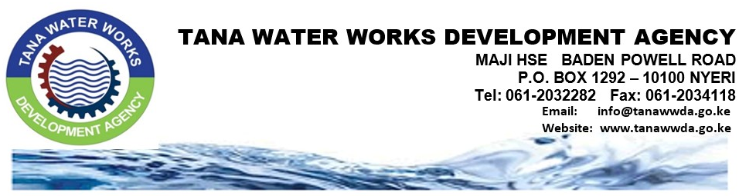
Nyeri, 15th January 2021
Press Release
For Immediate Release
Dear Members of Press

5 WATER COMPANIES RECEIVE EXHAUSTERS VALUED AT KSH 76.3 MILLION

Tana Water Works Development Agency is handing over 8No. Exhausters valued at Ksh 76.3 million to 5No. Water and Sanitation Companies. The exhausters will improve the sanitation levels of 298,124 people in the counties of Meru, Marsabit, Mandera , Kirinyaga and Tharaka Nithi. The exhausters will also create an additional revenue stream for the water service providers. The handing over exercise will be conducted at the Tana Water Works Development Agency in Nyeri.

Tana Water Works Development Agency has continued to implement capital works in various counties through the African Development Bank (AfDB) funded - Kenya Towns Sustainable Water Supply and Sanitation Program which is designed to improve access, quality, availability and sustainability of water supply in 19 towns and wastewater management services in 17 towns across the country.

The National Program is supported by the African Development Bank at a total cost of USD 391 Million which is approximately KES 42 billion for works and services of which the Government of Kenya will contribute a fraction of the total cost. The towns that will benefit from the program in the agency’s area are Kerugoya, Kutus, Chuka, Chogoria, Meru, Othaya, Murang’a, Mandera, Marsabit, Garissa and Isiolo which are earmarked to water and sewerage improvement under the Medium Term –III( MTP-III).

Tana Water Works Development Agency is implementing Six (6No.) ADB funded projects at a cost of Kshs9.12billion. They include; Kerugoya-Kutus Water Supply and Sanitation Project, Chuka Water Supply and Sanitation Project, Chogoria Water Supply and Sanitation project and Meru Sewerage, Marsabit Water Supply and Sanitation Project and Mandera Water and Sanitation Project and four (4No) Last Mile connectivity projects. These projects are expected to be completed in November 2021.
Sanitation is one of the most important aspects of community well-being. It protects human health, extends life spans, and is documented to provide benefits to the economy. The process of wastewater collection, conveying or treatment has the potential to generate and release odors to surrounding areas. Most odor problems occur in the collection system, in primary treatment facilities and in solids handling facilities as well as the sludge drying beds. The most frequently reported symptoms attributed to odors from wastewater treatment plant include headache, nausea, hoarseness, cough, nasal congestion, palpitations shortness of breath, stress, drowsiness, alterations in mood, and eye, nose, and throat irritation.

About Tana Water Works Development Agency
Tana Water Works Development Agency (TWWWDA) is one of the nine (9No.) Water Works Development Agencies established under the Ministry of Water, Sanitation and Irrigation following the enactment of the Water Act, 2016. TWWDA covers 5No. Counties namely: Nyeri, Kirinyaga, Embu, Tharaka-Nithi and Meru covering an area of 17,189.7Km² with a population of 3,917,065 people (Kenya Housing and Population census 2019).. The Agency aims to develop sustainable national public water and sanitation works that enhance socio-economic growth. In carrying out our duties, the agency intends to pull all its efforts towards improving water and sewerage infrastructure.

The Agency had a change of guard with a new Chief Executive Officer, Eng Phillip G. Gichuki who joined the Agency two months ago. He has a wide range of experience in the water sector.

Eng. Phillip G. Gichuki
CHIEF EXECUTIVE OFFICER
Ends

For more information contact:
Beato Migwi |Corporate Communication and PR Division | TWWDA
Tel: +254 720692254
Email: bmigwi@tanawwda.go.ke

Follow Tana Water Works Development Agency on:
Twitter handle: @tanawwda
Facebook : www.facebook.com/tanawwda/
Website : https://www.tanawwda.go.ke

